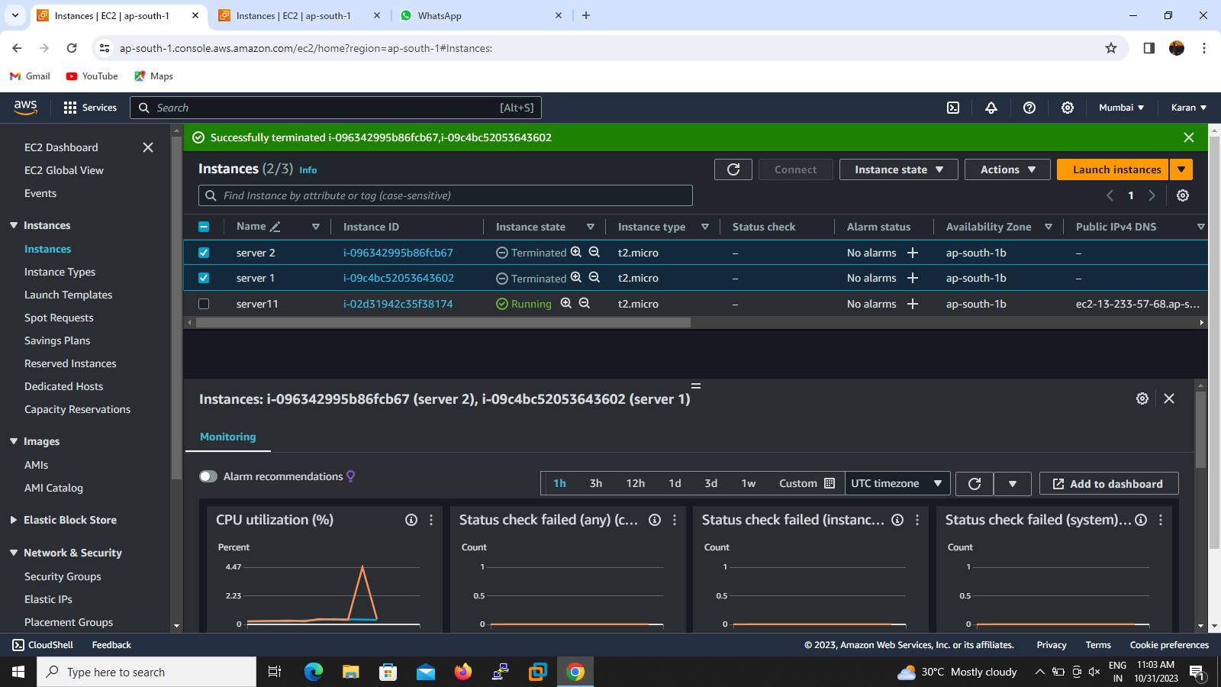

Elastic IP :

Elastic ip is called static IP ,elastic IP assigned for public IP address .elastic ip used for fixing the permanently for the instance

1).To create the new instance

2).Go to click elastic ip option then click allocate elastic ip address and it will be shows successfully allocated

3).then select the new created elastic ip and associate with a instance go to actions>associate>fill the the required instance and private ip address

4).go to instance and see the private ip address successfully changed ,if we can check stop the instance tand check the ip address will never change

